PROJECT 05-01
Noise Generators
See Fig. 5.2 for the shapes and parameters of the following noise probability density functions.
(a) Using function “imnoise” to add Gaussian noise to an image. You must be able to specify the
noise mean and variance.
(b) Using function “imnoise” to add salt-and-pepper (impulse) noise to an image. You must be
able to specify the probabilities of each of the two noise components.

PROJECT 05-02
Noise Reduction Using mean Filters and median filters
(a) Add salt-and-pepper noise to ‘ckt-board-orig.tif’, with Pa = Pb = 0.1 and show the noised image
(b) Program a 5 x 5 median filtering on (a) and demonstrate the restored result
(c) Further add Gaussian noise with specified mean and variance onto (a)
(d) Apply 5 x 5 Arithmetic Mean Filter, Geometric Mean Filter, Median Filter and Alpha-trimmed mean filter (adjusting the parameter d for your filter) on (c) respectively. Explain differences between your results
(e) Using the image difference and histogram technology to access the the performance of Alpha-trimmed mean filter and the Median Filter during the step (d)

PROJECT 05-03
Noise Reduction adaptive median filters
(a) Add salt-and-pepper noise to ‘ckt-board-orig.tif’, with Pa = Pb = 0.25 and show the noised image
(b) Apply 7 x 7 median filtering on (a) and show the processed image
(c) Design an adaptive median filter with maximum size of the subwindow as 7 x 7 on (a) and show the processed image
(d) Explain differences between your results.

PROJECT 06-01

Convert the RGB color image into gray image

- Read the color image” top_ left_flower.tif” in Matlab, you will obtain a 3-D array which denote the Red, Green and Blue component respectively.
- Use the equation I=(R+G+B)/3 to calculate the intensity. This is actually a simple way to convert the RGB color image into a gray image.
- Display the gray image.
- Adjust the proportion of R, G and B and re-calculate intensity I. Comparing with the result from (b) and discover the best proportions.
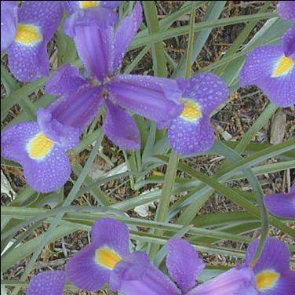

PROJECT 06-02

Intensity modification in color images

Now we wish to modify the intensity of the color image “Fig_strawberries” by suppressing it with a scalar of k=0.7 (which means I = 0.7*I) in both RGB color model and CMY color model
- Figure out how to suppress the intensity of the color image in RGB model according to PROJECT 06-01 and demonstrate the result
- Figure out how to suppress the intensity of the color image in CMY model according to the relationship between RGB model and CMY model, and demonstrate the result
